MID-YEAR EXAMINATIONS 2007

EXAMINATION BOOKLET

STUDENT IDENTIFICATION NUMBER

YEAR 12 APPLIED INFORMATION TECHNOLOGY – COURSE OF STUDY

TIME ALLOWED FOR THIS PAPER

Reading time before commencing work: Ten minutes

Working time for paper: Three Hours

MATERIAL REQUIRED/RECOMMENDED FOR THIS PAPER

TO BE PROVIDED BY THE SUPERVISOR

This Examination Booklet

TO BE PROVIDED BY THE CANDIDATE

Standard Items: Pens, coloured pencils, eraser or correction fluid, ruler
Special Items: Non graphic calculators permitted

IMPORTANT NOTE TO CANDIDATES

No other items may be taken into the examination room.

It is your responsibility to ensure that you do not have any unauthorised notes or other items of a non-personal nature in the examination room. If you have any unauthorised material with you, hand it to the supervisor BEFORE reading any further.

STRUCTURE OF THE PAPER

Paper | Questions Available | No of questions to  Be answered | Marks available
A: Multiple Choice | 1 - 20 | ALL | 20
B: Short Answers | 21-26 | ALL | 30
C: Extended Answers | 27 - 28 | ALL | 50
D: Production | 29 | ALL | 100
Total |  |  | 200

Total Marks = 200

INSTRUCTIONS TO CANDIDATES

Attempt all questions and write your answers on this examination booklet

Marks available for each question are given at the beginning of the question or in the rubric of each part.

Extra pages for answering or making rough notes are available throughout this booklet.

PART A: Signify your answer by circling the label (a, b, c, or d) of the correct response. If you change your answer, completely erase your original answer and indicate the new one clearly. Questions where two or more responses are selected will score no Marks.

PART B: Write your answers in the spaces following each question.

PART C: Write your answer in the places indicated.

SECTION A MULTIPLE CHOICE /20

Circle the answer that BEST completes the question.

Suggested working time for this section is 20 minutes.

- Random access memory is used to:

  - Store data permanently
  - Remember keystrokes and store cookies
  - Store data temporarily
  - Store data onto the hard drive

- Computer graphics data like pictures, frames of a movie, drawings, or frames of an animation are represented by a grid of:

  - Spots
  - Pixels
  - Dots
  - Blobs

- A systems performance is affected primarily by:

  - Amount of RAM, Type of Processor, Clock Speed, Clock width
  - Type Ram, Processing Speed, Clock Speed, Type of processor
  - Amount of Ram, Secondary storage, Processing speed, Clock speed
  - Amount of Ram, Type of Processor, Clock Speed, Bus width.

- Which of the following is not a principle of design?

  - Line
  - Unity
  - Contrast
  - Rhythm

- You have a raw image which you need to put on your website. You are keen to ensure that download speeds are maximised so your end users are not left frustrated by lagging. You do not however, want to compromise on quality. Which of the following sequences represent your picture from smallest through to the largest file formats?

  - Png, jpeg, tiff, gif
  - Gif, jpeg, tiff, png
  - Jpeg, tiff, png, gif
  - Gif, tiff, png, jpeg.

- A modem is designated by the term 56K. To what does the number 56 refer?

  - Speed at which the modem can transfer data
  - Number of K type pins on the connecting cable
  - Maximum amount of data buffered by the modem
  - The digital standard support by the modem

- The series of input, process, output and storage, is sometimes referred to as the:

  - Computer programming cycle
  - Information processing cycle
  - Data entering cycle
  - Web browsing cycle

- As smart phones and PDA’s continue a trend of offering similar functions, it is becoming increasingly difficult to differentiate between the two devices. This is known as:

  - Installing
  - Mobile computing
  - Digital Convergence
  - Telematics

- Recorded audio that can be stored on the web and downloaded to a media player is known as:

  - Blog
  - Wiki
  - Portal
  - Podcast

- Which of the following techniques would not be used to improve web searches?

  - List all possible spellings
  - Read a search engine’s Help information
  - General nouns and put the most important terms last
  - If a search is unsuccessful, try another search engine.

- Identify which of the following is incorrect.

  - A worm resides in active memory and replicates itself over a network
  - A virus replicates itself by attaching itself to programme files
  - A trojan watches for a certain condition or event and is activated when that even occurs
  - Viruses conceal themselves by either hiding in fake code or changing the code as it infects.

- Utility software is not

  - Programs written to support the successful use of application software
  - Computer Aided Design (CAD)
  - A pop-up blocker
  - Software that compresses file sizes.

- For a display device to show images as defined by a video standard, both the display device and the graphics processing unit must:

  - Be the same size
  - Contain a heat sink or fan
  - Use an analog signal
  - Support he same video standard

- Which of the following is not a video file format?

  - .mov
  - .DIVX
  - .RAM
  - .PDM

- Video and animation programmes generally use with most widely used frame rate which is:

  - 30 fps
  - 12 fps
  - 20 fps
  - 57 fps

- Which of the following are competing, high-capacity DVD recordable formats?

  - DVD-R and DVD+R
  - BD-R and HD DVD-R
  - DVD-RAM and DVD-ROM
  - BD-RE and BM-W

- Which of the following is the best safeguard against unauthorised access and use?

  - Audit trail
  - Firewall
  - User names and passwords
  - Biometric device.

- Which of the following would not be put in an Organisations IT code of conduct?

  - Employees shall consider the social impact of programs and systems they design
  - Employees should always use the computers in a way that demonstrates consideration and respect for fellow humans
  - All employees must have their driver’s license numbers displayed in all emails for identification purposes.
  - Computers may not be used to bear false witness.

- ‘The relationship in scale between one element and another, or between an object and one of it’s parts’

Which of the following design principles best fits this definition?

  - balance
  - proportion
  - rhythm
  - unity

- An Australian artist posts something onto a creative commons website. Do they have the right of attribution if it is used for commercial purposes?

  - It depends on which creative commons website they posted the image onto.
  - The artist has the moral right of attribution.
  - No because they have waived their copyright when they accepted the creative commons agreement.
  - No, they posted it into the public domain so therefore have no right to attribution.

SECTION B SHORT ANSWER /30

- There are six questions in this section
- Attempt all questions.
- Write you answers in the spaces provided.
- Each question is worth 5 marks and diagrams may be used

Suggested working time for this section is 30 minutes

- Explain the difference between a .fla and a .swf file. When are these files used and why? 5 marks

22. Two storyboard formats are shown below. 5 marks

Format 1

Format 2

Identify and describe an appropriate use for each format in a multimedia presentation.

- Once you know which application software you are going to buy, what important hardware features would you examine and consider when purchasing a computer to ensure that performs at the level you require?
5 marks

- Explain why a laptop would not be recommended as a primary computer within a business. How can you ensure that you minimise the impact of occupational overuse syndrome when using these devices? 5 marks

- Identify TWO methods of animating images and describe the differences between these methods. 5 marks

- Explain what Web 2.0 is and discuss some of its features with reference to the internet. 5 marks

SECTION C EXTENDED ANSWER /50

- There are two questions in this section
- Attempt all questions.
- Write you answers in the spaces provided.
- Each question is worth 25 marks and diagrams may be used

Suggested working time for this section is 50 minutes

- “Copying photos, music or movies from the internet is as easy as point and click. But just because it’s easy, doesn’t mean it’s legal.”

Baxter, E. (2007). The rise of the armchair thieves. The Age, August 27,2007. Retrieved 2 May 2008 from http://www.theage.com.au/news/web/rise-of-the-armchair-thieves/2007/08/25/1187462576081.html

Discuss and elaborate on the issues raised in this statement with reference to the Copyright Act and subsequent amendments to this Act.

Copyright Act 1968 (1 mark) 1 mark

Cannot copy data as even if copyright assigned -
Reference to Moral rights (1mark)
amendments of 2000 (1 mark)
which cannot be assigned (1 mark) including:
Right of attribution (1 mark)
Right to remuneration if used (1 mark)
Right not to be denigrated (1 mark)

Use of example to illustrate moral rights (say creative commons)– 3 marks
9 marks

Private use (1 mark), specifically space shifting (1 mark) for music example (1 mark, ie.,, can space shift onto different media – cd - ipod).
Amendments of 2006 (1 mark)
Can time shift tv and radio programs (2 marks)
Can format shift books but not video to DVD. (2marks)

8 marks

Public domain v publicly available (2 marks). Definition of public domain – copyright extinguished (1 mark), publicly available does not mean public domain (1 mark) 4 marks

Reference to Fair Dealing provisions (1 mark) and what (1 mark)/how (1 mark) it refers to (education say 1 chapter, 10% or non-commercial) 3 marks

- With over 140.000 known computer viruses and 85,000,000 spam emails sent out each day, the likelihood of your PC coming into contact with malware such as viruses, worms and spyware is almost guaranteed. And once your computer becomes infected with malware, simple tasks such as browsing the web can be very frustrating as your computer’s speed is drastically decreased – that is if you can still connect to the internet at all. Given the prevalence of malware, the only real long-term solution is preventing it from infecting your computer altogether, but how?

Identify and discuss the various home and business solutions available to prevent this scenario developing.

Home/Business

Firewall – what it is and does 3 marks

Install and update anti-virus software 3 marks
Eg., 1 mark

Install and update anti-spyware software 3 marks
Eg., 1 mark

Strengthen Web browser security – upgrades 2marks

Install latest Operating system updates (OS) sp2 + auto updates 2 marks

Disable file sharing on hard drives 2 marks

Be cautious when downloading 1 mark
Eg 1 mark

Handle email attachments carefully 1 mark
Eg 1 mark

Do not click on all email links – phishing 2 marks

Protect your passwords 2 marks
Eg., don’t use too simple a password – use a strong one at least 7 characters long with a mix of lower and uppercase letters and digitals 2 marks

Change passwords regularly 1 mark

Protect your wireless network/any network 2 marks
Eg., via encryption 1 mark

Email filters 2 marks

Adds up to more than 25 – OK but max is 25.

SECTION D PRODUCTION /100

- This question is worth 100 marks.
- Use A4 and A3 sheets provided.
- You may use diagrams, illustrations and coloured pencils in this section.

Suggested working time is 80 minutes

- Production Question

There is a high failure rate amongst first year dentistry students. Students come into the School of Dentistry wanting to continue working part-time but the compulsory attendance to lectures, spread over all hours of the working day, over 5 days of the week, makes it very difficult for students to continue working.

The administration is considering allowing students to access the lecture notes and recordings, assignments, previous examinations remotely and provide online collaboration for assignment discussion with lecturers and students.

Using the A3 and A4 pages attached you are to create a design solution for a multimedia product that will afford the students greater flexibility in combining their work and study lives.

On page 17 is a screen shot of the current website.

You will be required to go through the design and proposal process ensuring the following:

- You must identify a target audience
- You are to develop a clear statement of intent
- You must briefly identify the technology you will use and why
- You must identify and develop appropriate design criteria
- You must develop initial concepts/designs – use A3 paper at end of booklet.
- Your final design is to be annotated with reference to design criteria – use A3 paper at end of booklet.
- You are to evaluate your proposed solution against your target audience, statement of intent and design criteria.

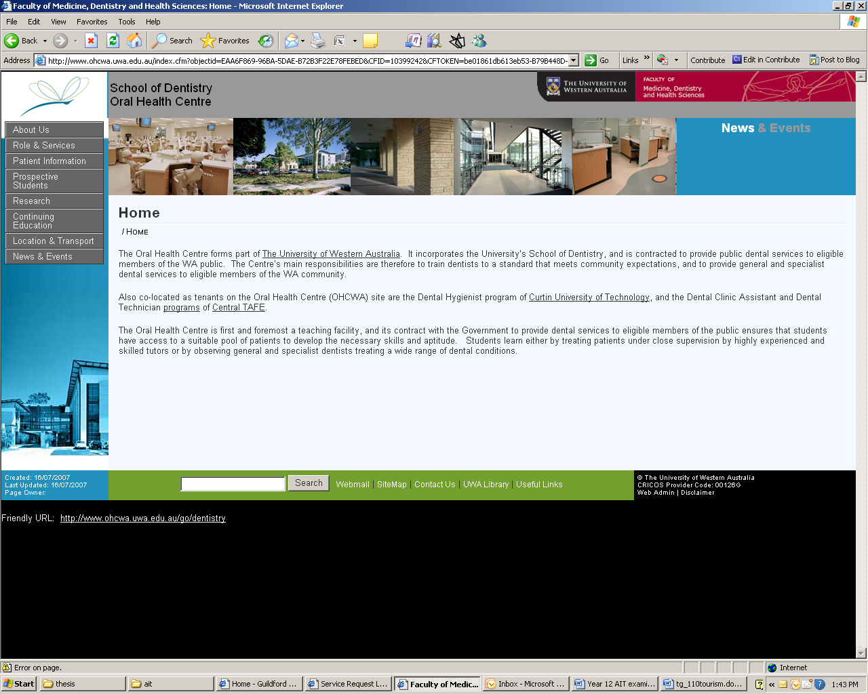

Marking Guide – students need to recognise that a hypermedia player may be the best as long as accessibility issues are addressed.
Target Audience | Identified target audience (1 marks) based on age (1 mark), education (1 mark), faculty (1 mark), socio-economic (1 mark), work/life balance ( 1 mark). More than 5 marks. | 5 marks
Statement of Intent |  | 5 marks
Technology | Hardware –identifies need internet connection (1 mark), logical processing and storage capacities (2 marks), mentions security of data (1 mark),logical input/output devices (2 marks).  Software – correctly identified what software used to publish (say Dreamweaver/Frontpage – 2 marks), what software used to develop elements (flash, fireworks, photoshop, illustrator ) (2 marks), browser compatibility and why use a particular type of software (ie, flash needs plugins.2 marks). File sizes for software and download speeds ( 1 mark). Accessibility issues associated with HTML v Flash (2 marks) | 10 marks
Design Criteria | Functional from brief ie., (maximum 8 marks)  Must be compatible with current set up – looks like HTML/CSS therefore flash will be (2 marks)  Use of frames – may not suit but may not want to change navigation too much in case students do not recognise new set up (2 marks)  Online collaboration – Web 2.0 technologies – ie., links to forums (2 marks)  Must be able to put lecture notes/audio up – podcasting – reference to external folders (2 marks)  Ability to contact lecturers/tutors/students (2 marks)  Recognition that the new design must be able to handle multi/hyper media (2 marks)  Aesthetic (maximum 10 marks)  Balance – may be that students recognise that dentistry students take themselves quite seriously so do not need funky asymmetrical design. Formal balance or standard web structure would produce more formal/professional look. Some students will argue for more contemporary design as long as they justify choice – OK (2 marks)  Colour – given from brief – recognition that theme needs to continue – recognition that red opposite green therefore contrast on colour chart but blue next to green = analogous but all cool with contrasting red for vibrancy (2 marks somewhere)  Logo – recognition that logo will need to be the same (2 marks) Repetition  Fonts – some recognition that there are limited fonts and that they are sans serif for readability purposes. Student may not recognise specific font – but will recognise that it is sans (2 marks)  Alignment – It is left aligned – why (2 marks)  Unity – some reference to keep designs unified 1 mark  Harmony – looks good – harmonious design – 1 mark  Functional (7 marks)  File types – swf, html, jpeg, gif (2 marks)  Portability – ie., viewed over browser, emailing clients etc (2 marks)  File sizes for download speeds.(2 marks)  Recognition that maybe gif OK because limited gradation in colours (1 mark)  Reference to compression techniques (1 mark)  Reference to inserting URL’s etc. (1 mark)  Reference to external files (1 mark) | 25
Initial designs | At least 2 logical designs (2 marks each – maximum of 6 marks)  Reference to design criteria in annotations (1 mark per design criteria – maximum of 8 marks)  Some comparisons made to indicate final – ie., some form of evaluation why one is better than the other with reference to target audience (4 marks) | 20
Final plans | Reference and justification against Design Criteria – maximum of 8 marks.  Annotations clearly explain link to Target Audience – maximum of 4 marks  Designs clear and easy to follow both logic and design (3 marks) | 15
Evaluation | Against target audience – 4 marks  Against design criteria – 8 marks  Against technology and software being used – 4 marks  Identification of potential problems – 2 marks  Comparison against other known commercially available products 2 marks | 20

Following A3 Sheets are for question 29 initial concepts, preliminary and final designs.

